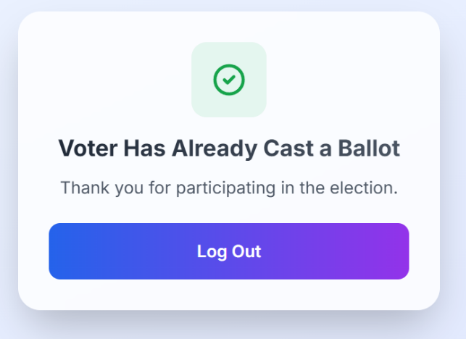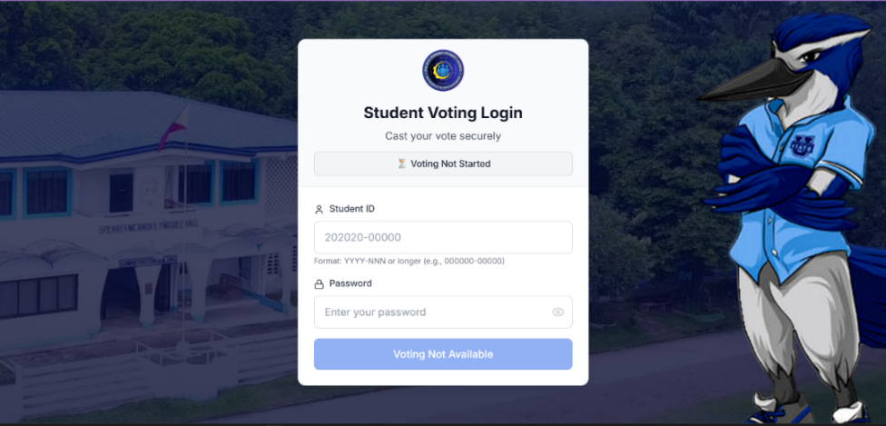**LOGIN FORM (VOTER)**

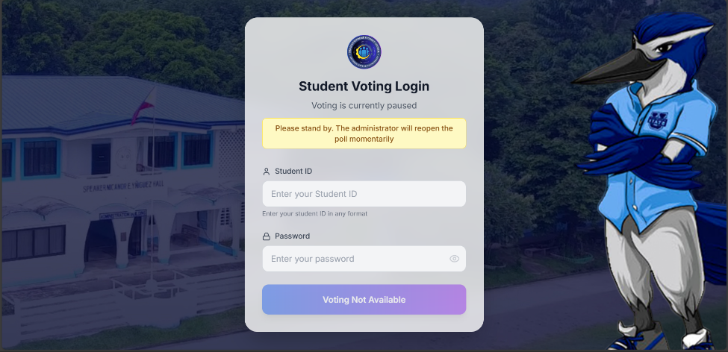

**If voter already casted their vote when login again**

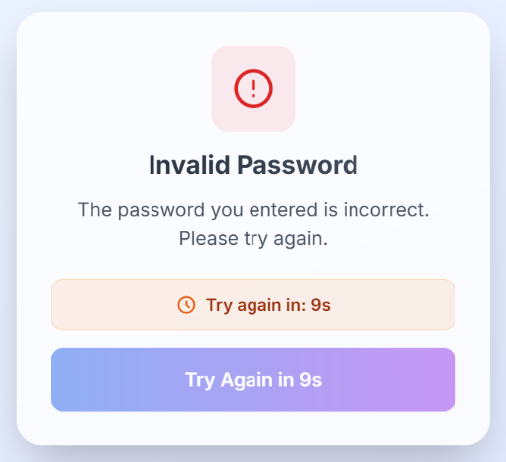

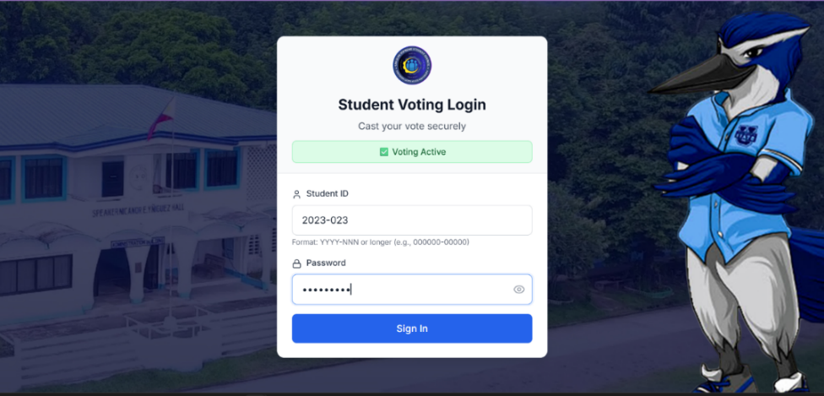

**Voter Error Message when Login with invalid password**

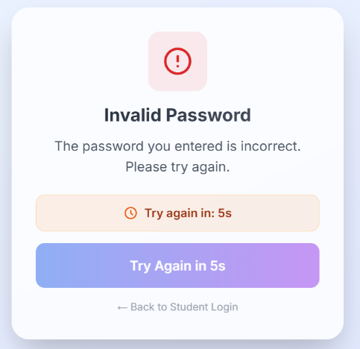

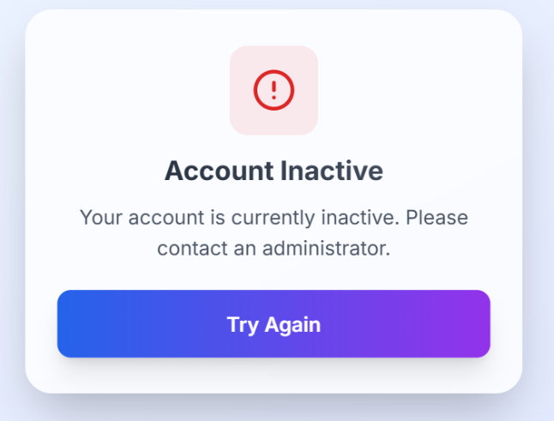

**Admin Error Message when Login with invalid password**

**Voter Inactive Error Message when Login with invalid password**

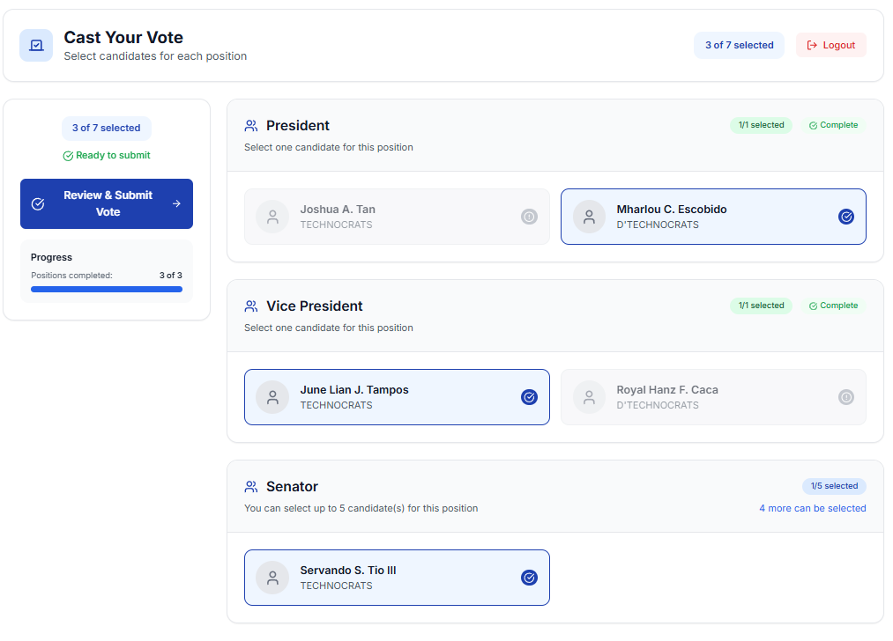**CAST VOTE FORM (CASTVOTE.TSX)**

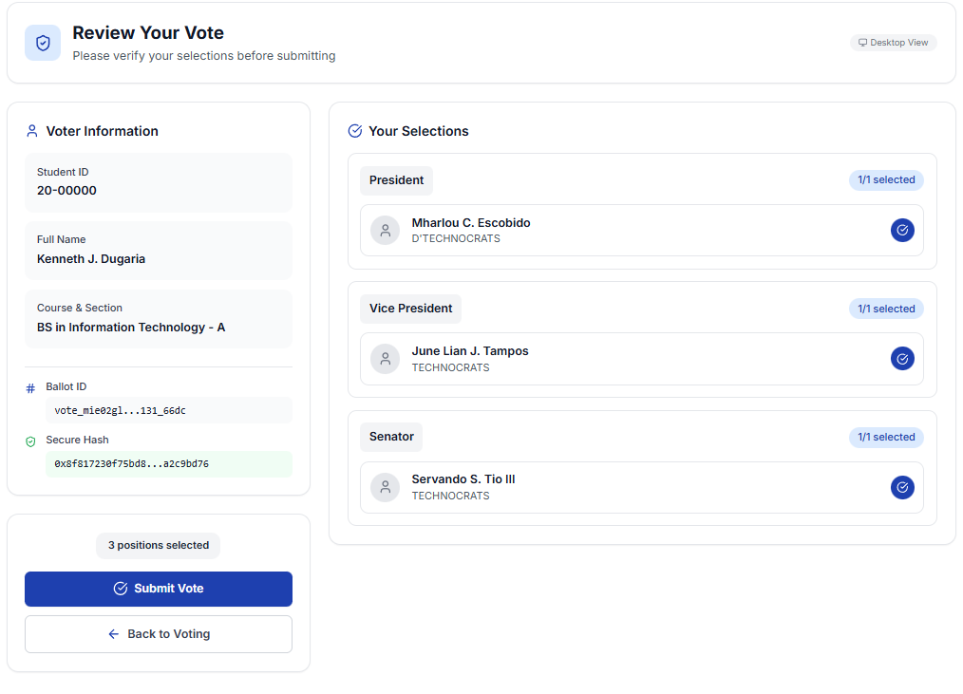**REVIEW VOTE (REVIEWVOTE.TSX)**

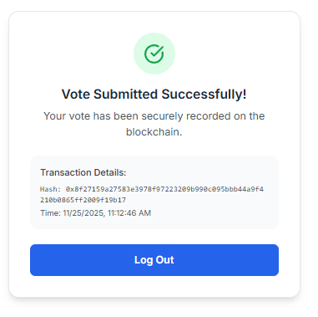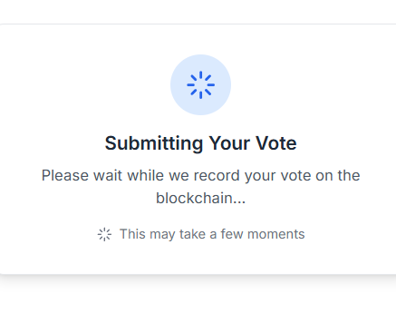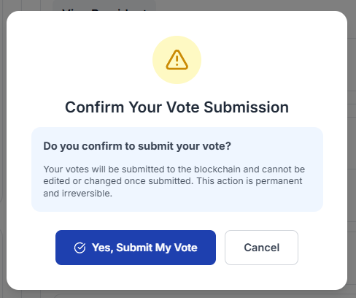**Receipt/Confirmation Form/Modal:**

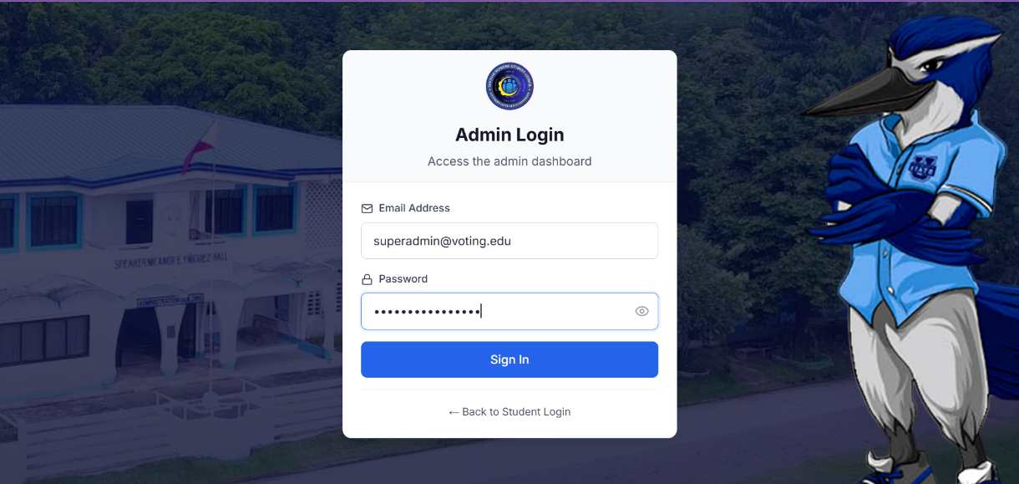**Admin Login Form:**

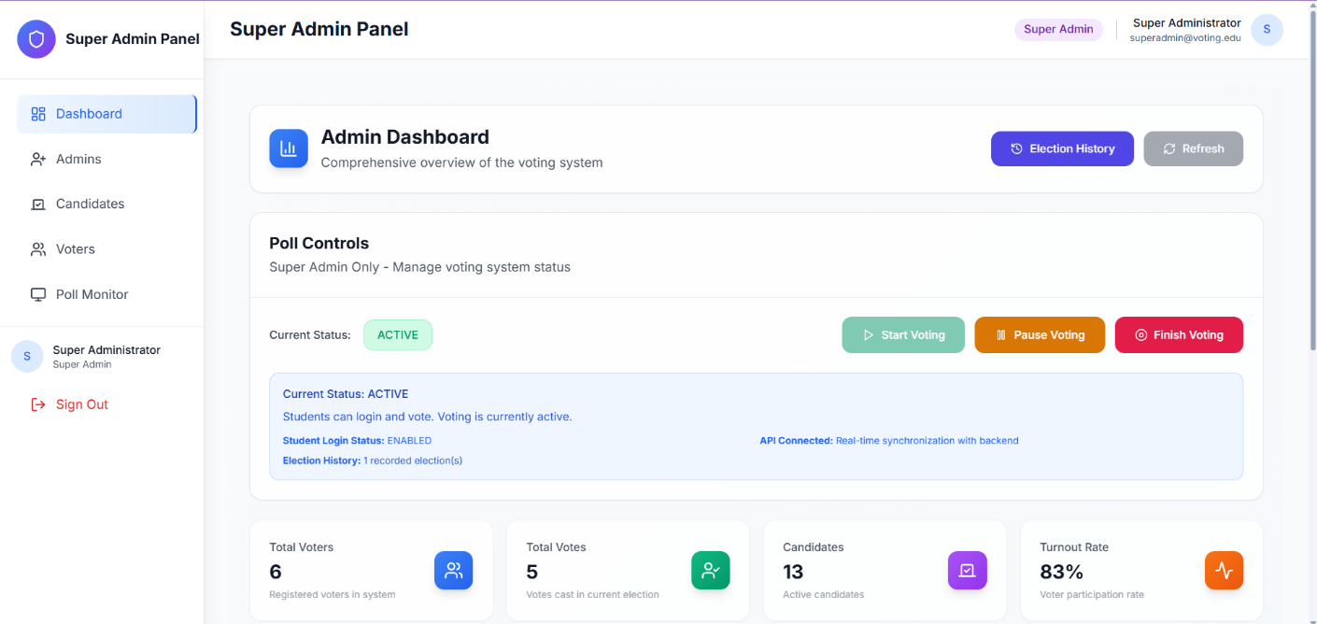**Super Admin Dashboard (super admin login):**

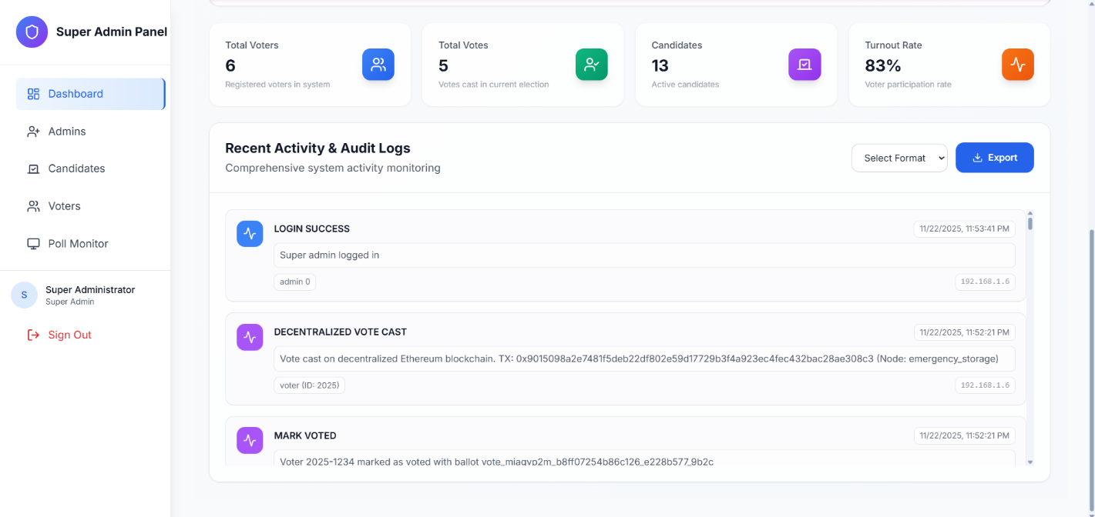

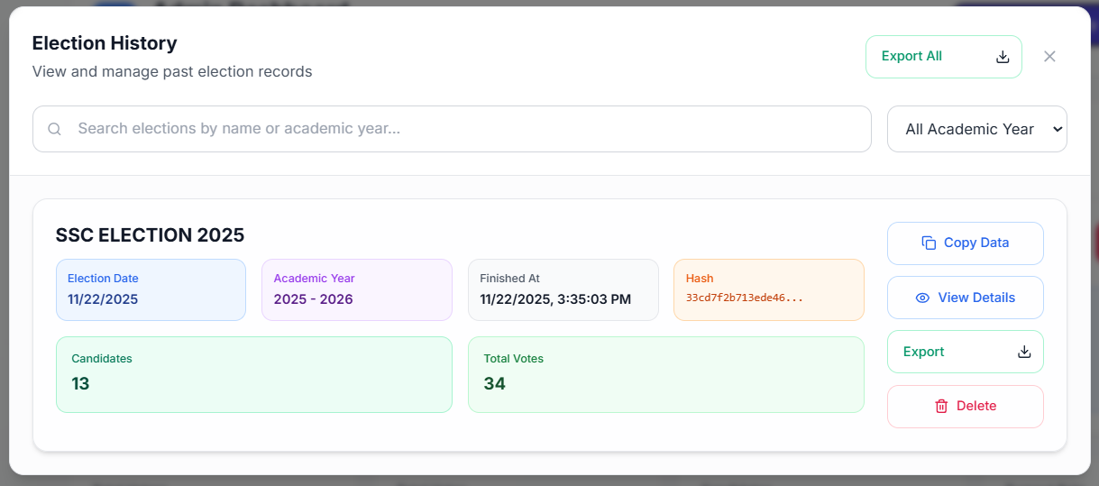**Election History Form/Modal (Election History Button):**

**VIEW DETAILS ELECTION HISTORY MODAL**

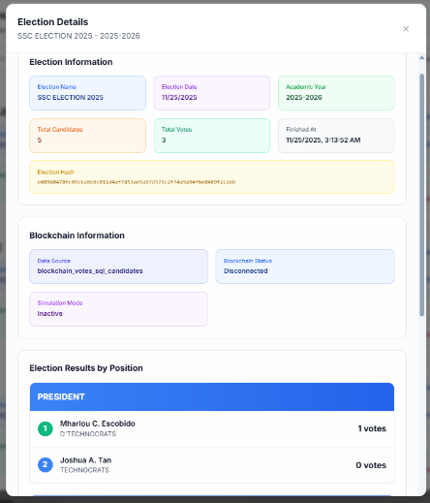

**Finish Election Form/Modal (Finish button in poll controls) when finish election pressed it will go to Super Admin Authentication modal then it will save and reset the blockchain database**

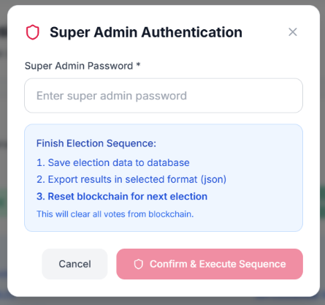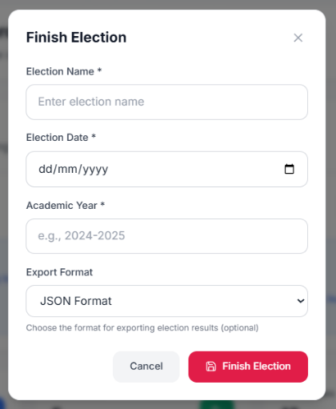

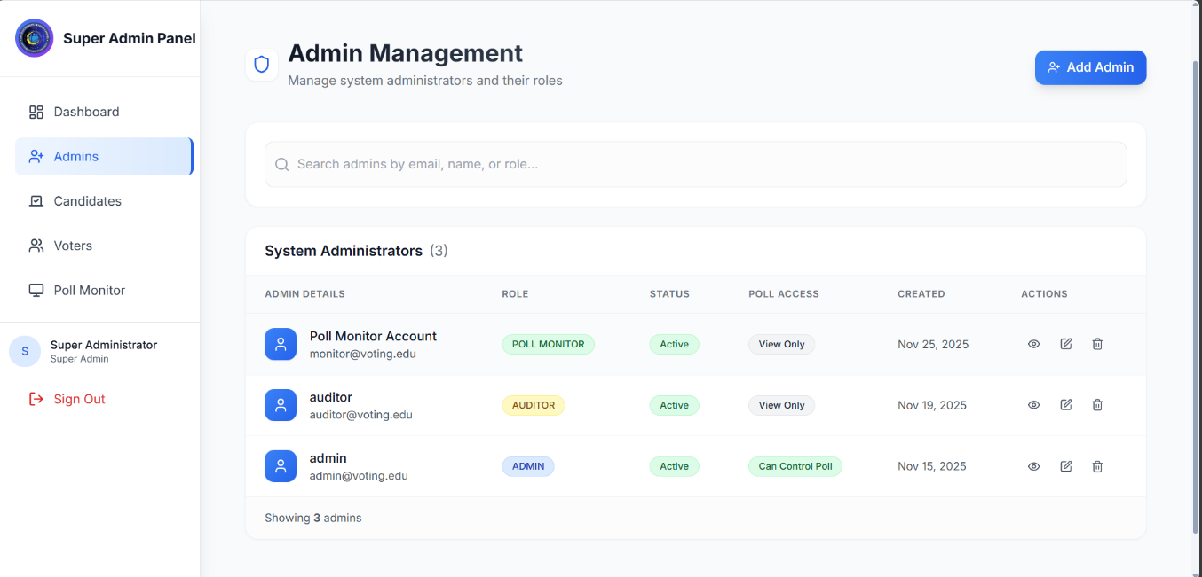**Admin Management Dashboard (Super Admin Login and Super Admin Access only):**

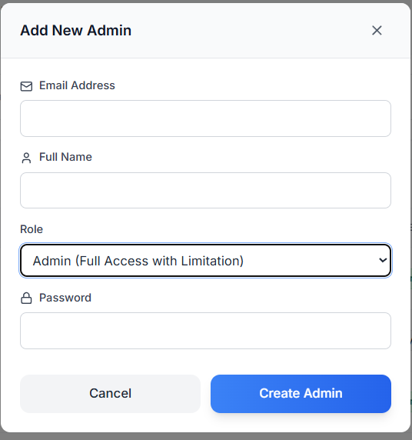**Add Admin Form/Modal:**

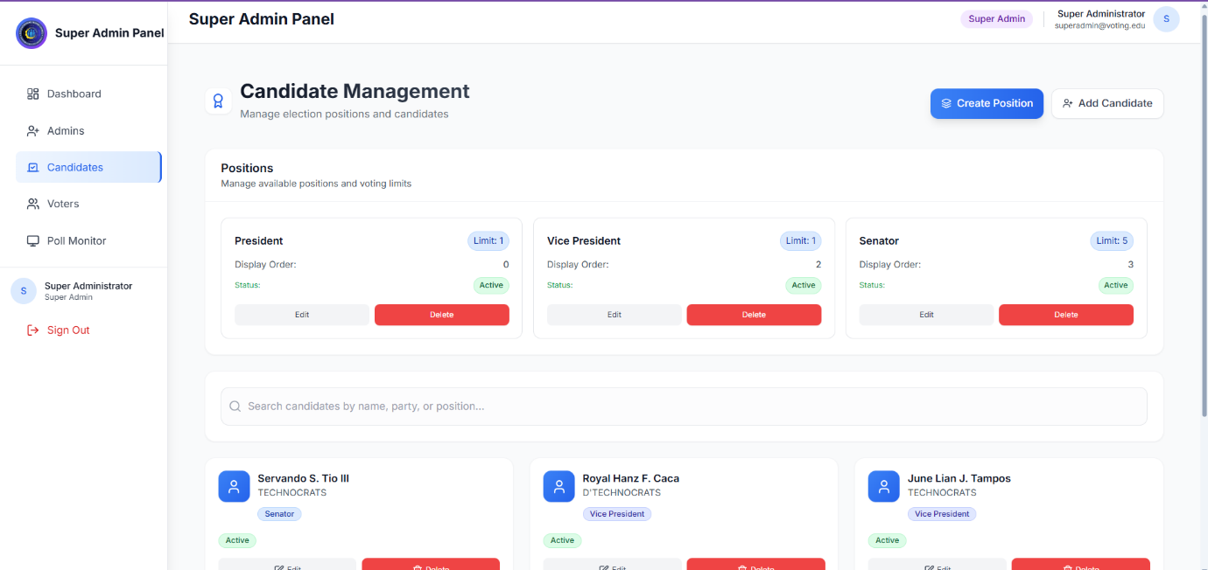**Candidate Management Dashboard (All buttons are Disable when Voting Start):**

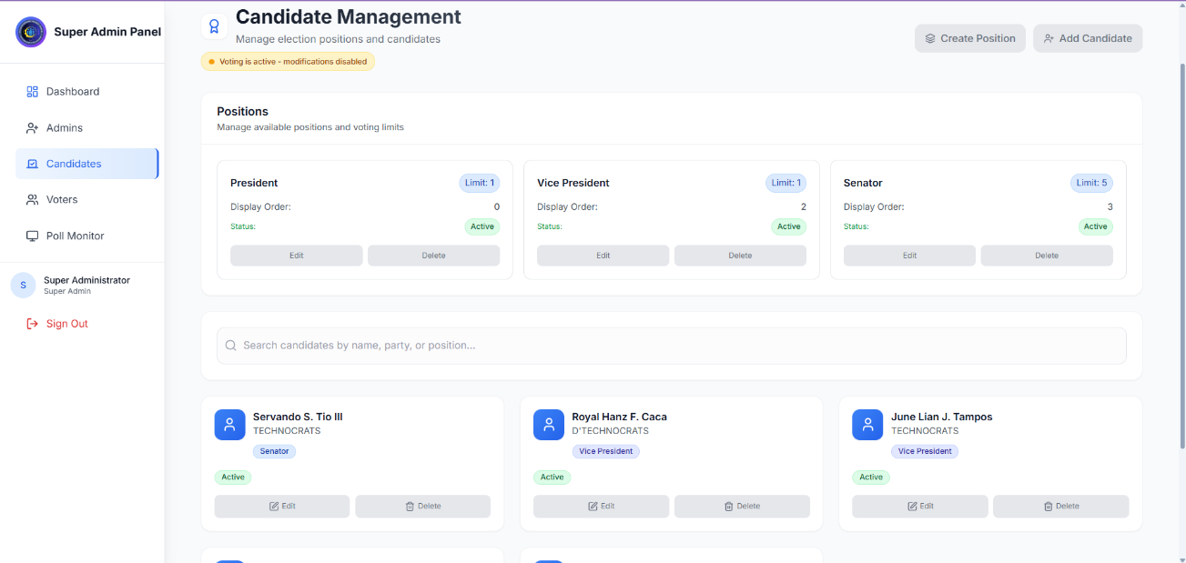**Voting is Started or Voting Active:**

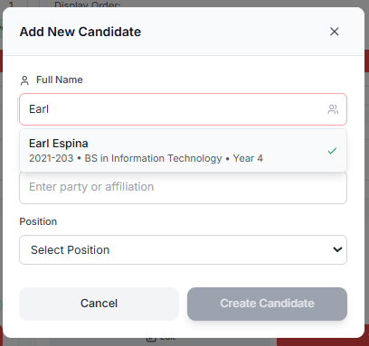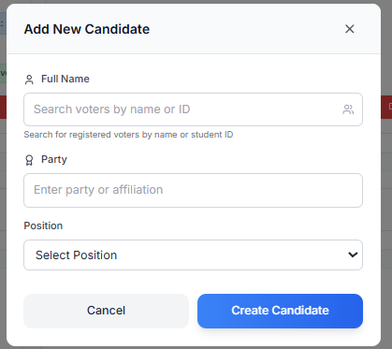**Add New Candidate Form/Modal (Full Name Textbox will highlight red if candidate exist):**

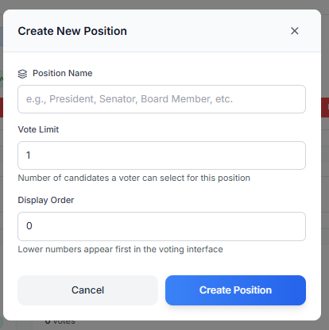**Create New Position Form/Modal:**

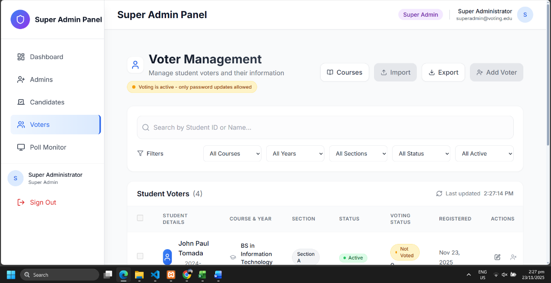**Voter Management Dashboard:  
voting is active**

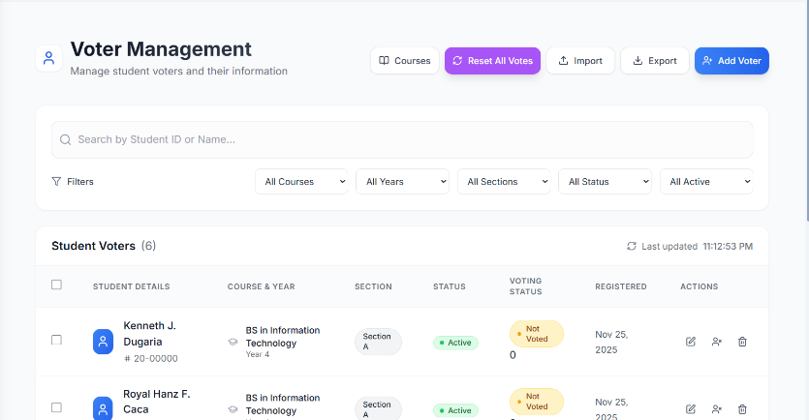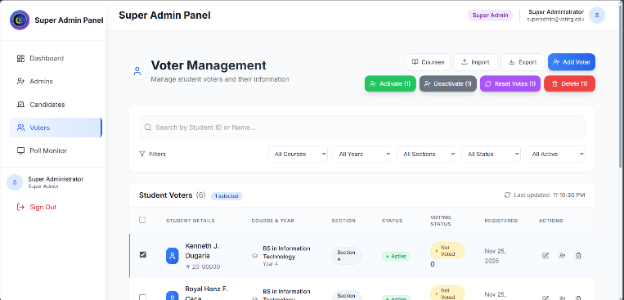**Voting pause or stopped and with a selected voter (additional Buttons will popup if finish Reset All Votes button shown also)**

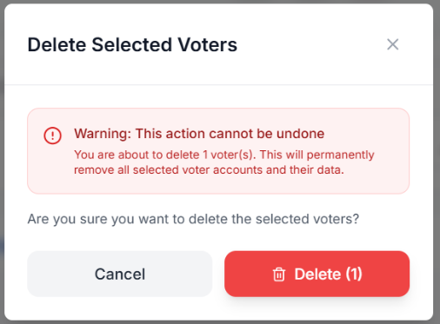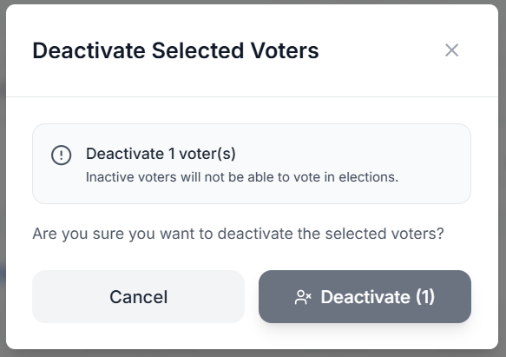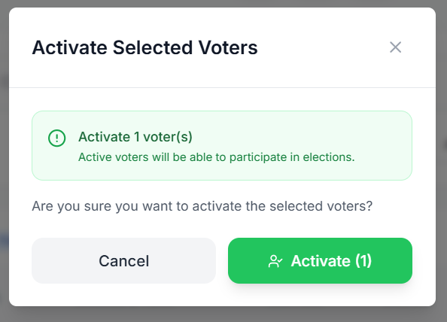

**Delete Selected Voter will only show if you select a voter**

**Deactivate Selected Voter will only show if you select a voter**

**Activate Selected Voter will only show if you select a voter**

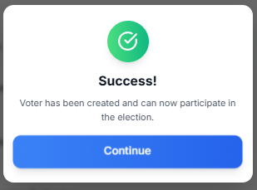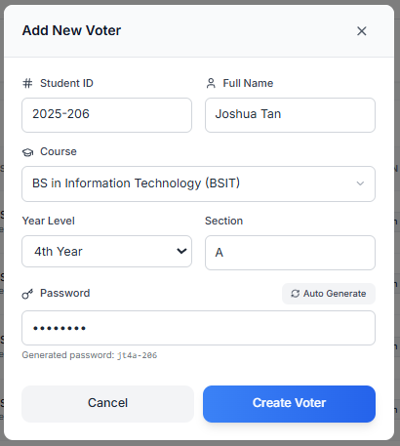**Add Voter Form/Modal:**

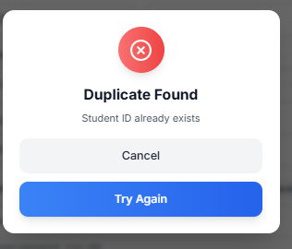

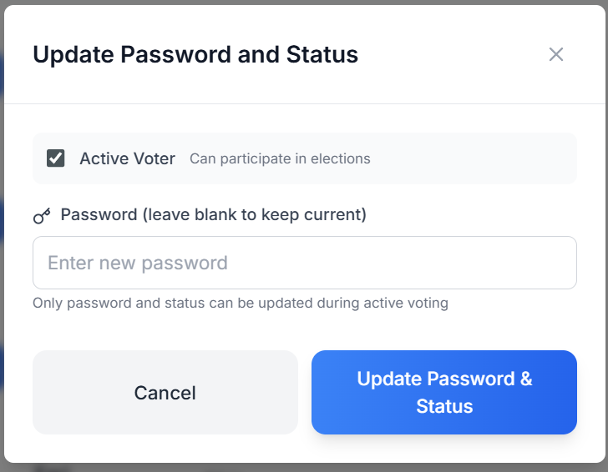**Edit Voter Modal/Form if Voting is Active update status Active/Inactive also:**

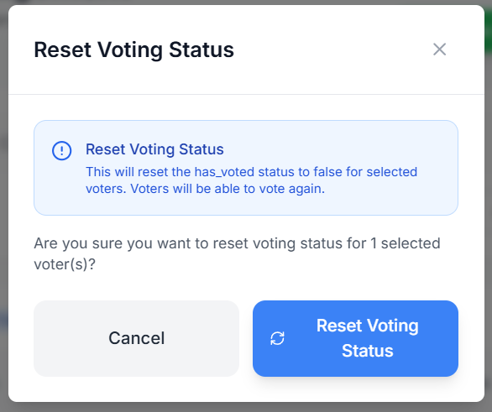**Add Courses Form/Modal: Reset Voting Status If Student Selected:**

**Export Form/Modal:**

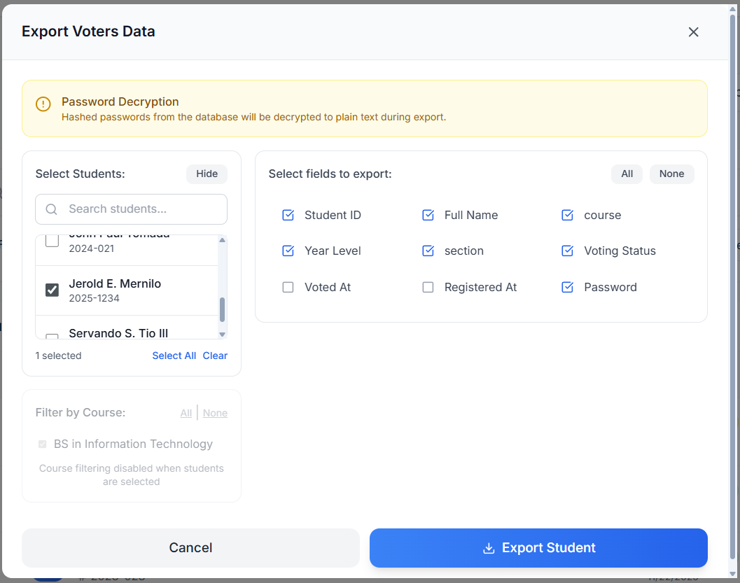**Specific Select Student/Voter**

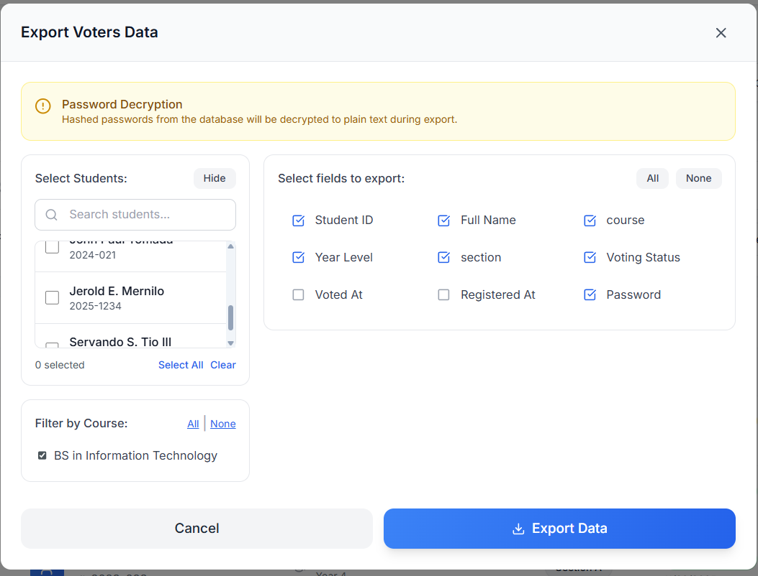**By Course Selection:**

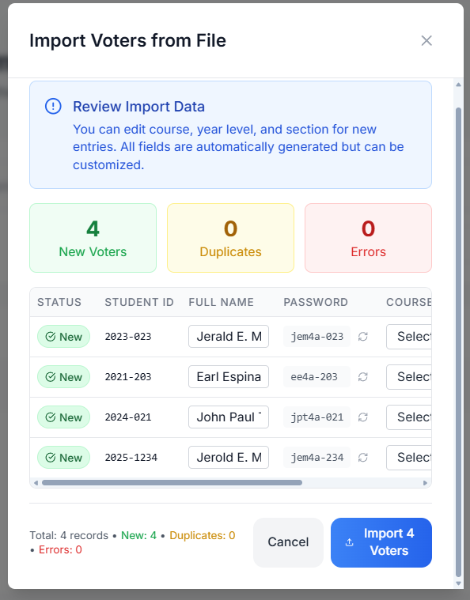**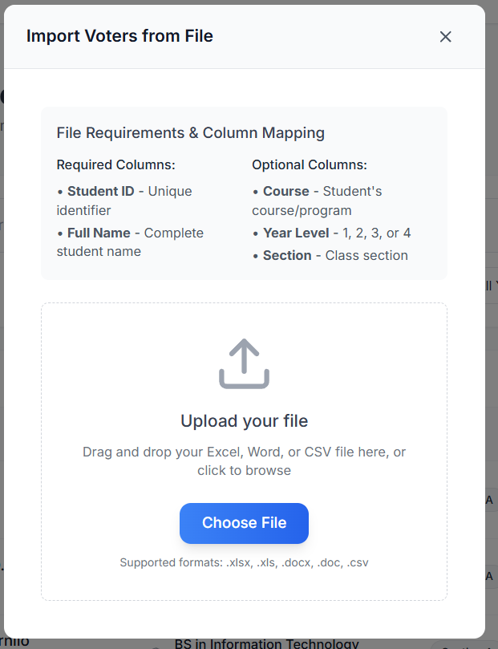Import Voters Form/Modal:**

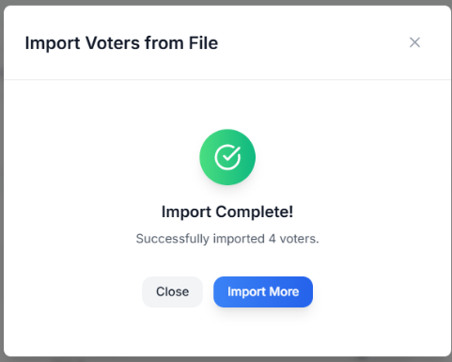

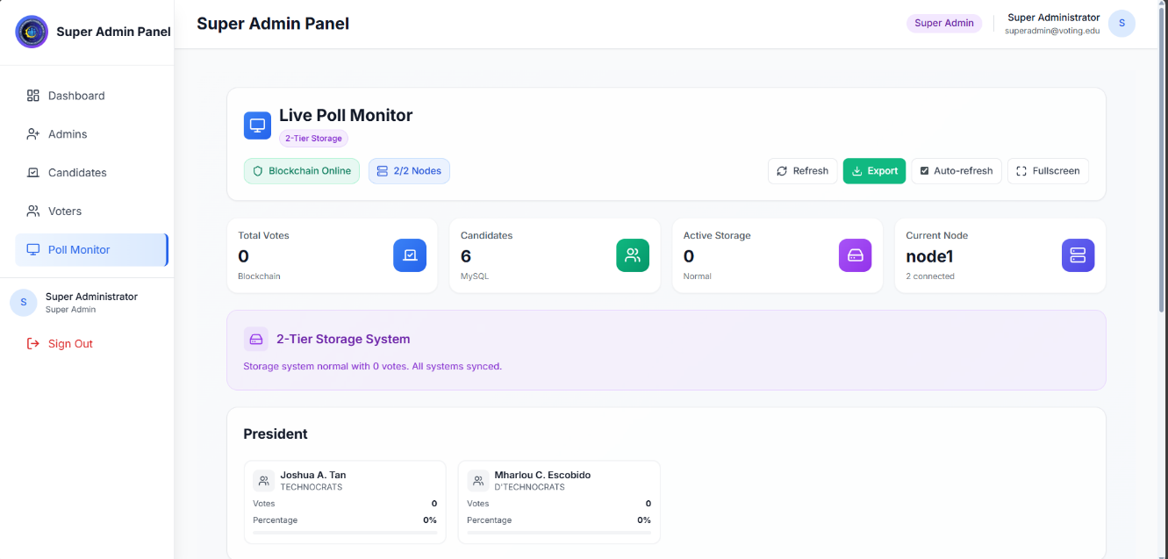**Poll Monitor Dashboard (Super Admin Logged in):**

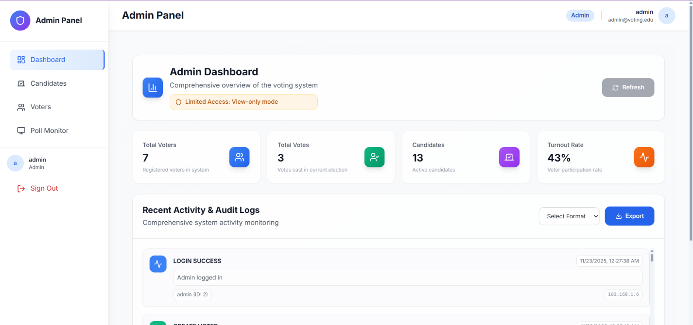**Admin Dashboard (if Admin role is logged in):**

**Poll Monitor Dashboard (if Admin role is logged in. Active Storage will only count on 1 specific storage connected to fetch data):**

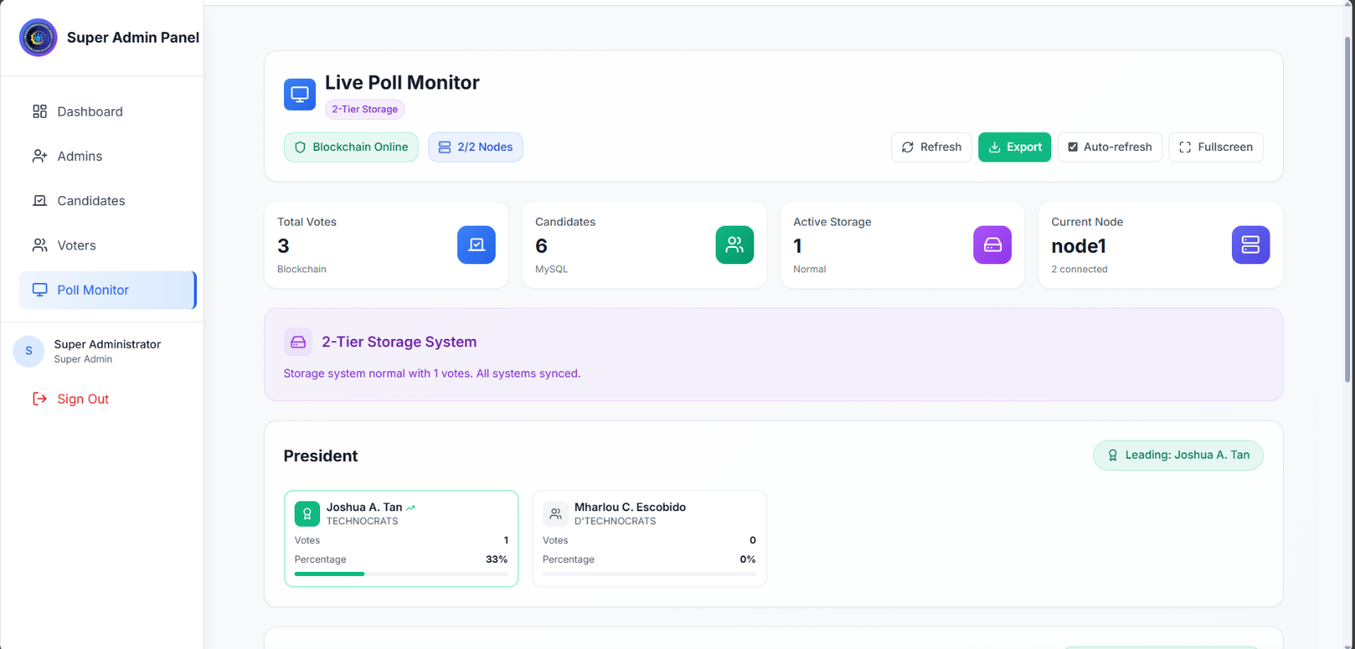

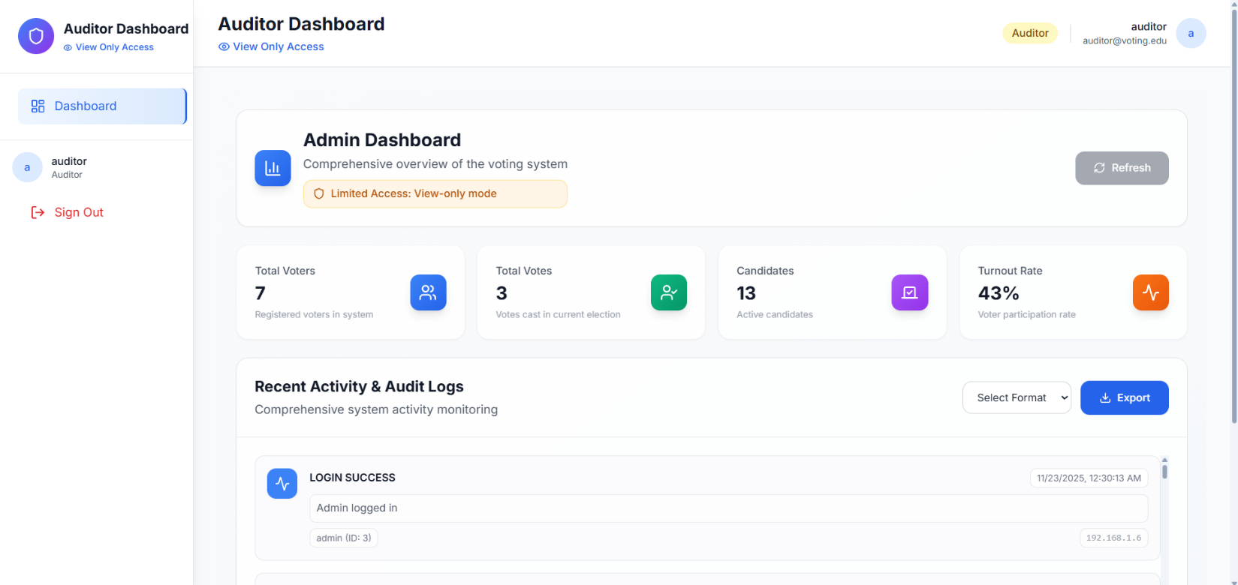**Auditor Dashboard (if Auditor role is logged in):**

**Poll Monitor Dashboard (if Poll Monitor role is logged in):**

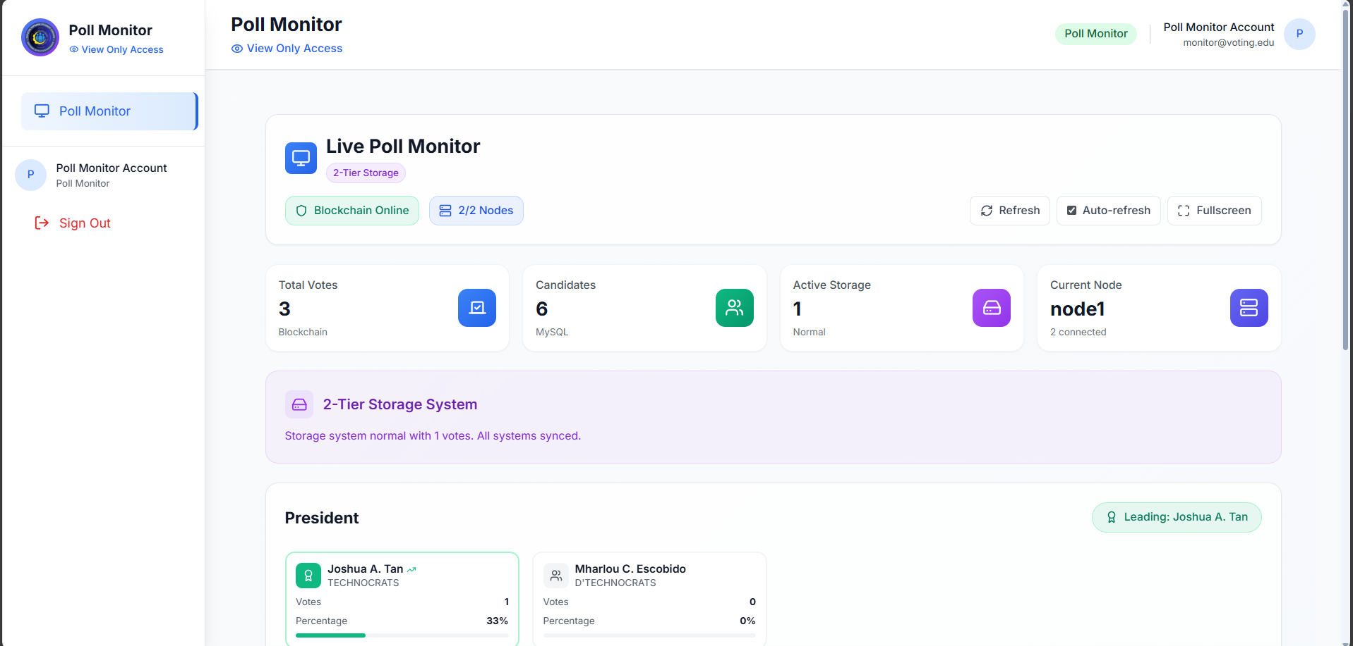

**If Node 1 is down Node 2 will take over because node 2 is the backup but if node 1 restarted or start running again it will sync the node 2 data to the node 1 then node 1 will be the primary again. Also both node will receive both data if vote casted:**

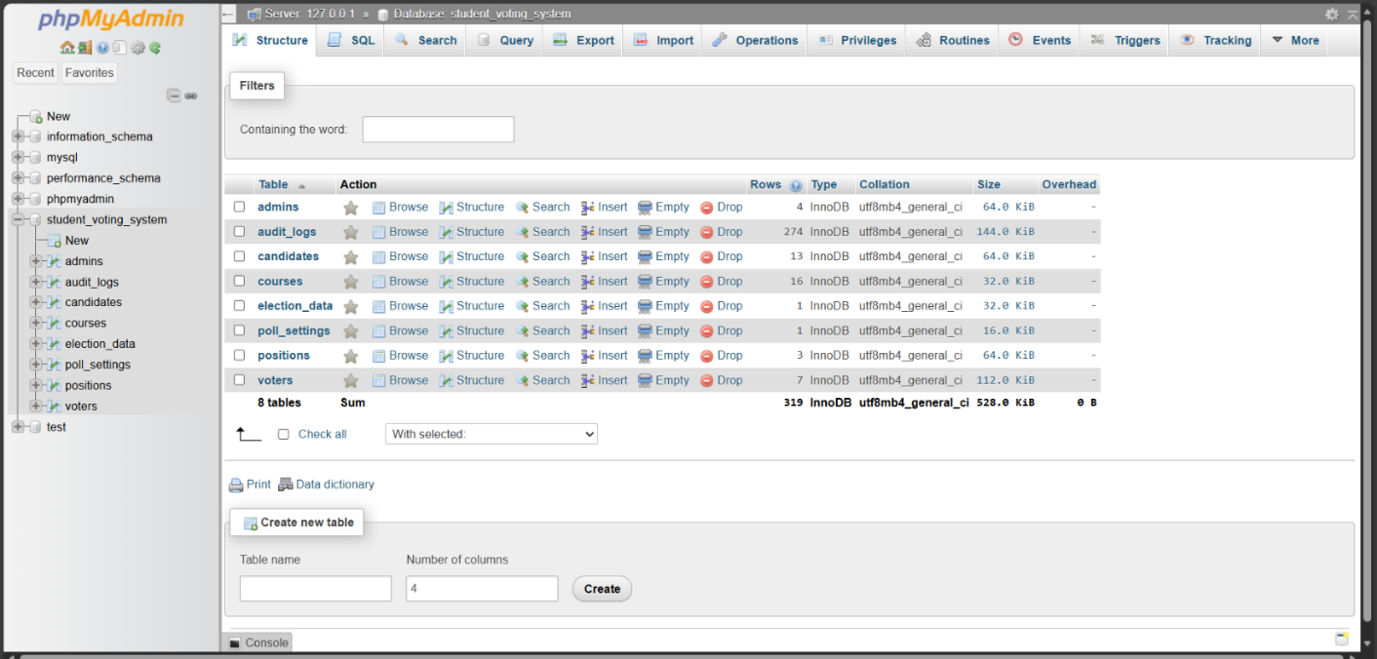**SQL Database:**

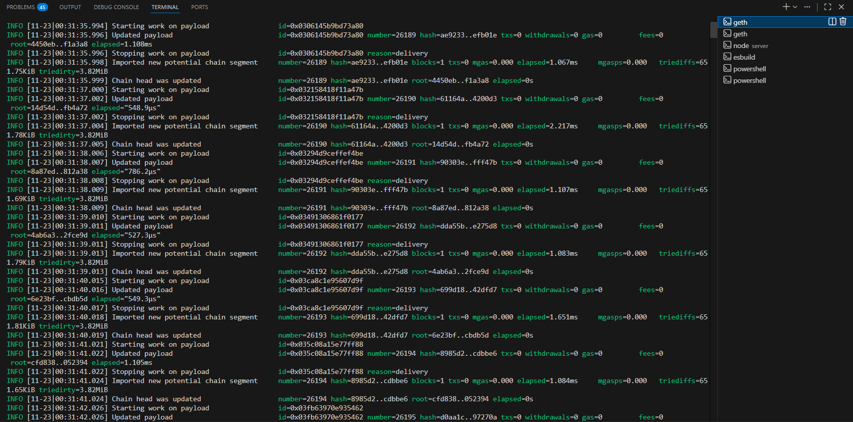**Node 1 (Blockchain Geth Ethereum)**

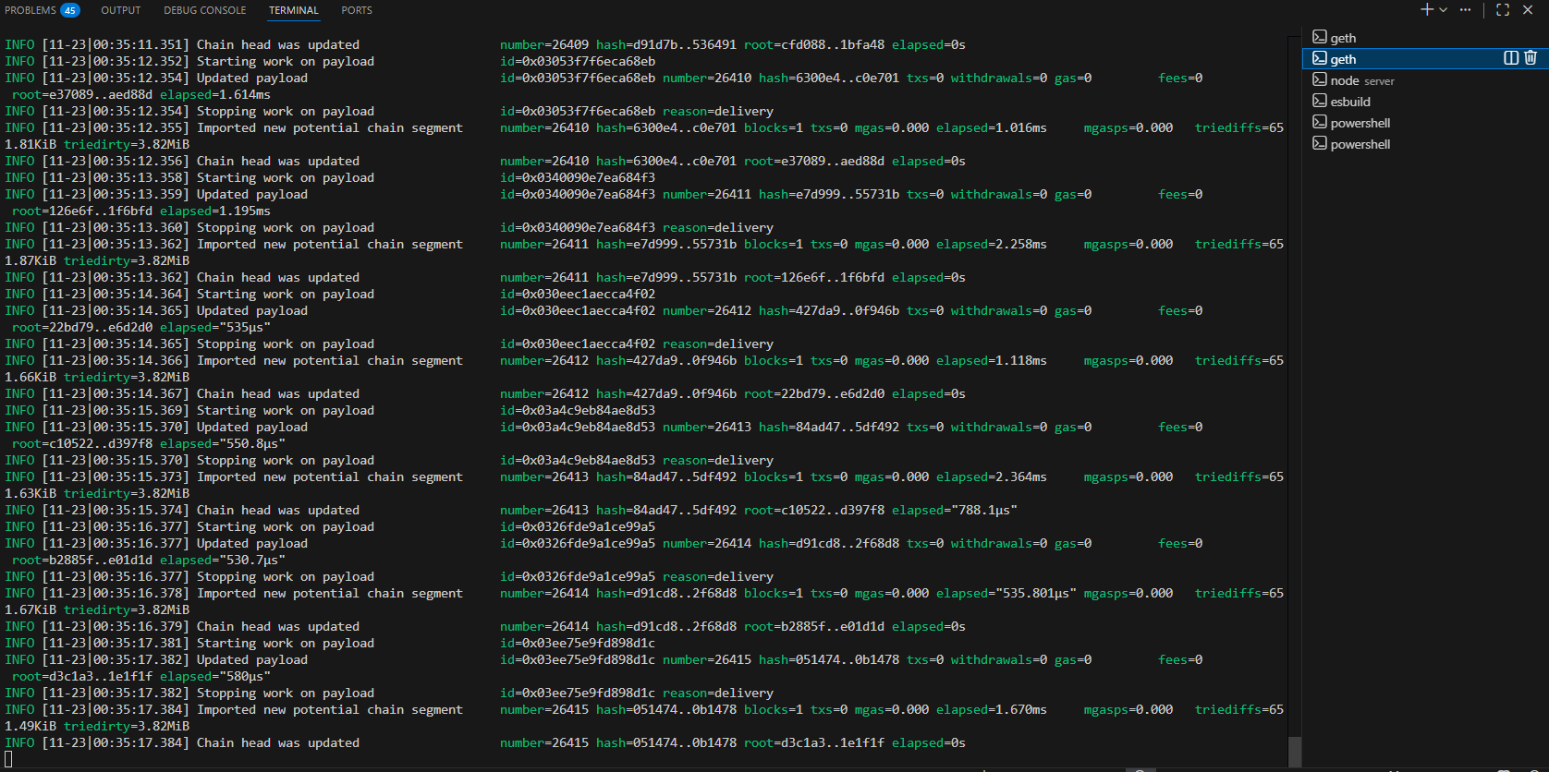**Node 2 (Blockchain Geth Ethereum)**